URL for UAT
- https://thedoctorssdev.wpengine.com/

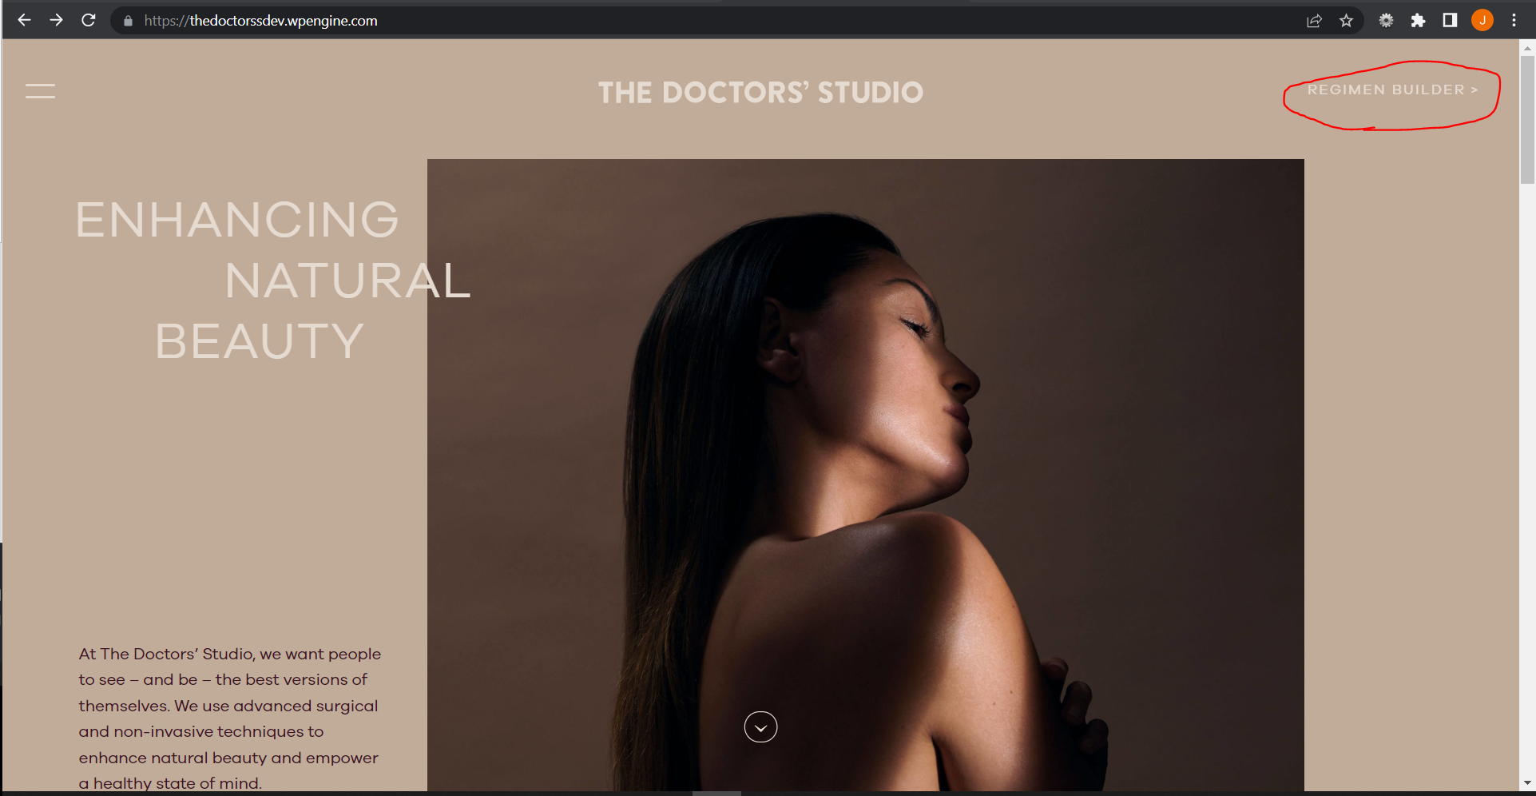

URL for Survey:
- https://thedoctorssdev.wpengine.com/regimen-builder/

The output of the Search Results:
